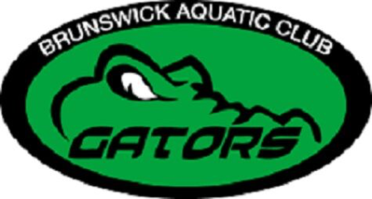

Scholarship Information and Selection Criteria

Brunswick Aquatic Club (BAC) will award a limited scholarship to a student(s) based on the following criteria to be reviewed by the Selection Committee.

Applicants must be an active or recent member of BAC, in good standing, at time of graduation. Scholarship recipients will be selected on basis of BAC involvement, academic accomplishment, and engagement in their community. The recipient will be notified no later than May 30th.

Any graduating student of a Brunswick County School, including charter schools, home schools, private schools, and Early College are eligible to apply. Students must graduate with a minimum of a 3.0 GPA (B) and be applying to a 2 or 4 year college or vocational school. Applicant must provide their current High School transcript and acceptance letter from the college or vocational school of their choice with their application.

The application process will be open through April 1st and the application must include all parts and forms to be considered. Other documentation may be requested by the Selection Committee as necessary. Application to be mailed in full to the following address:
Brunswick Aquatic Club, 786 Marsh Rose Path NW Calabash NC 28467, postmarked by April 1st.

Applicant Information

Name:

Applicant’s Home Address:

Home Phone:

Participant’s Email:

Date of Birth:

High School: GPA:

Colleges applying to:

Participant Signature: Date:

Applicant Essay

Complete the following written essay. Each essay should be typed and a minimum of 500 words. Please use the space below or attach separate pages. If attaching separate pages, please make sure your name is at the top of the page.

What impact has the sport of swimming made on your life and how have you assisted Brunswick Aquatic Club in reaching its mission statement?

Our Mission
To empower Brunswick County's emerging generations to be the best they can be, for a lifetime in and out of the water. While providing a safe and supportive environment for a competitive swimming regiment, our swimmers can develop a positive self-image while learning commitment, leadership, and goal setting skills.

Activities Chart

Please list any relative life experiences with a brief description. Please use the space below or attach separate pages. If attaching separate pages, please make sure your name is at the top of the page.

A. Extracurricular/School Activities

B. Community/Volunteer Service

C. Awards & Recognition

